Alex Mekovsky
COSC 320
Enyue Lu
5/3/2023
Lab 11 Report
I have successfully finished the lab and everything associated with the directions in the lab page. Here is the output from the computer below.

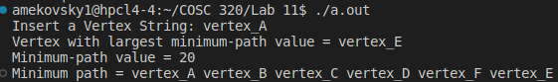
Overall this lab took me an hour and a half to successfully complete. My biggest issue with the lab is implementing the minimumPath function, as I struggled with finding the right implementations and structures needed to properly process and display the information needed. After getting help and assistance from classmates and other sources, I was able to successfully complete the lab and everything associated with it.

